The TianShan Overall Architecture
Version: 0.1
Author: Hui Shao
Document Status: |  | WorkInProgress (W) |  |  | Draft (D) | Issued (I) | Released (R)
Revision History:
Date | Version |  | By | Description
1/10/2007 | 0.1 |  | Hui Shao | Initial Draft
10/20/2008 | 0.2 |  | Hui Shao | Added event and monitoring, volume in ContentStore and some corrections

Contents

1. Introduction 1
1.1 Purpose 1
1.2 Scope 1
1.3 Conformance Notation 1
1.4 Definitions, Acronyms, and Abbreviations 2
1.5 References 2
1.5.1 Supplemental Documents 2
1.5.2 Normative References 3
1.5.3 Informative References 3
2. Background and Goals 4
2.1 Background 4
2.2 Services to Be Supported 4
2.3 Goals of TianShan On-Demand Architecture 5
2.3.1 Open Headend 6
2.3.2 Multiple Headend Support 6
2.3.3 Shared Headend 6
2.3.4 Shared and Dynamic Resource Management 6
3. Overall Architecture 7
3.1 Reference Architecture Description 7
3.2 Logical Components 9
3.3 Interfaces 9
3.4 Stream Transport Network Abstraction 10
3.4.1 Entities 10
3.4.2 Linkages 11
3.4.3 A Stream Transport Path 11
3.4.4 Evaluation and Selection 11
3.4.5 Non-cached and Cached Streaming 12
3.5 Session and Resource Management 13
3.6 Virtual Hosting 13
3.6.1 Quota Management 13
3.6.2 Typical Deployment Configuration 14
3.6.3 Transactions and Statistic 14
3.7 Core work flow 14
3.7.1 Setup an On-Demand Session 14
3.7.2 Purchase Resolving and Quota Validation 15
3.7.3 Session State Diagram 16
3.7.4 Stream Control 16
4. Logical Component Descriptions 18
4.1 Content Store 18
4.1.1 Content Store Service 18
4.1.2 Content Provision Engine 18
4.2 Stream Service 19
4.3 Session and Path Management Kit 19
4.3.1 Session Manager 19
4.3.2 Business Router 20
4.3.3 Path Manager 20
4.3.4 Path Helper 20
4.3.5 The Weiwoo Service 20
4.4 Resource Manager 20
4.4.1 Content Caching 21
4.4.2 Conditional Access and Encryption 21
4.4.3 Streaming Network and Devices 21
4.5 Client Application 21
4.6 Client Request Gateway 22
4.6.1 The RTSP Proxy 22
4.7 Value-add Application 22
4.7.1 Application Service 22
4.7.2 Asset Resolving 22
4.7.3 Propagation and Replication 23
4.7.4 Ingestion Management 23
4.7.5 Asset Navigation 23
5. Interface Descriptions 25
5.1 ICE Basic 25
5.2 Manageable Services 26
5.3 Content 26
5.3.1 ContentStore (T3) 26
5.3.2 Content (T3.1) 27
5.3.3 Provision (T3.2) 27
5.4 Stream 27
5.4.1 StreamService (T5) 28
5.4.2 Stream and Control (T5.1) 28
5.4.3 Playlist (T5.2) 28
5.4.4 Conditional Stream Control (T5.3) 29
5.5 Session and Resource 29
5.5.1 Session Manager (T1) 30
5.5.2 Session and Control (T1.1) 30
5.5.3 Resource Descriptors (T1.2) 30
5.5.4 Path Manager (T1.3) 31
5.5.5 Path Ticket (T1.4) 32
5.6 Path Helper 32
5.6.1 Path Helper Object (T4.1) 32
5.6.2 Path Helper Manager (T4.2) 32
5.7 Application and Purchase 33
5.7.1 Purchase Resolving (T1.5) 33
5.7.2 Application Service (T2) 33
5.7.3 Purchase (T2.1) 33
5.8 Asset Distribution (T6) 34
5.9 Navigation 34
5.10 Billing (T8) 34
5.11 Client Request 34
6. Architectural Recommendations 34
6.1 Overview 34
6.2 Dummy Resource Management 34
6.3 Broadcast Applications 34
7. Appendix 34
7.1 ContentStore and StreamSmith on SeaChange MediaCluster 34
7.2 ChannelOnDemand Application for PauseTV 34

Introduction

Purpose
The objective of this specification is to detail the TianShan On-Demand Architecture. This architecture will be open and flexible in supporting a variety of interactive digital video services including Video-On-Demand, PauseTV, ScheduledTV and so on.

Scope
This document is primarily focus on the overall infrastructure architecture and interfaces among different headend components and the interfaces between headend components and client devices (e.g., digital set-top box or other video-enabled device). This document does NOT address the following aspects:
- Digital Set-Top Box(STB) requirements and architecture
- End user applications (e.g. user interfaces)
- Billing interface and integration

Conformance Notation
Through this document, words that are used to define the significance of particular requirements are capitalized. These words are:
“MUST” | This word or the adjective “REQUIRED” means that the item is an abosolute requirement of this specification. The word “MANDATORY” may be used in lieu of “MUST” in certain circumstances
“MUST NOT” | This phrase means that the item is an absolute prohibition of this specification
“SHOULD” | This word or the adjective “RECOMMENDED” means that there may exist valid reasons in particular circumstatnces to ignore this item, but the full implications should be understood and the case carefully weighed before choosing a different course.
“SHOULD NOT” | This phrase means that there may exist valid reasons in particular circumstances when the listed behavior is acceptable or even useful, but the full implications should be understood and the case carefully weighed before implementing any behavior described with this label/
“MAY” | This word or the adjective “OPTIONAL” means that this item is truly optional. One vendor may choose to include the item because a particular marketplace requires it or because it enhances the product. For example, another vendor may omit them same item.

Definitions, Acronyms, and Abbreviations
The following acronyms are used throughout this specification document:
TianShan | The TianShan On-Demand architecture
Streamer | - A device on the Stream Server that can be used to pump network streaming traffic with one physical connection to the successor component in a network topology. It is also called as streamer device  - A descriptor refer to a streamer device in Stream Transport network abstraction
Stream Server | A machine that consists of one or a number of streamer devices.
Stream Service | A software service that implements TianShan StreamService interface definition, it may run on a Stream Server
Storage | - A physical storage, refer to one single file volume if there are no additional indications.  - A descriptor refer to a ContentStore instance in Stream Transport network abstraction
Content Store | A software service that implements TianShan ContentStore interface definition. It refers to a single file volume
Service Group | A group of destination client applications
Session | An entity describes the context and lifecycle of an on-demand order. It refers to a server session if there are no additional indications
Client Session | An entity describes the content and lifecycle of a client order existing in client request gateway

References

Supplemental Documents
[S-1] TianShan Architecture SDK Documentation, TianShanSDK.chm, Hui Shao
[S-2] TianShan Architecture / Stream Transport Network Abstraction and Resource Management, Hui Shao
[S-3] TianShan Architecture / The Video Server, Hui Shao
[S-4] TianShan Architecture / Virtual Hosting – Application, Quota and Licensing, Hui Shao
[S-5] TianShan Architecture / The Architectural Comparison with other On-demand Technologies, Hui Shao

Normative References
[N-1] ISO/IEC 13818-6: MPEG-2 Digital Storage Media Command and Control
(DSM-CC)
[N-2] ISO/IEC 13818-1: MPEG-2 System
[N-3] ISO/IEC 13818-2: MPEG-2 Video
[N-4] IETF RFC 2326, Real Time Streaming Protocol (RTSP)

Informative References
[I-1] Distributed Programming with Ice, ZeroC
[I-2] Pegasus Session Setup Protocol, Version 1.0 and Version 2.1, Time Warner Cable
[I-3] Pegasus Lightweight Stream Control Protocol, Version 1.0, Time Warner Cable
[I-4] Pegasus Interactive Service Architecture Version 1.3, Time Warner Cable
[I-5] ATSC A/52, ATSC Digital Audio Standard
[I-6] ATSC A/53, ATSC Digital Television Standard
[I-7] ATSC A/65, Program and System Information Protocol for Terrestrial Broadcast and Cable

Background and Goals

Background
As of today, various interactive video systems are being deployed by cable operators to offer compelling video on demand services. Those systems are usually achieved by tightly integrating and customizing various components such as asset management system, session and resource management system, billing and entitlement system, network transport, as well as the set-up client applications. Although a number of successful stories are recently seen on news, various configurations of the systems have led the business getting more complex. Since the components were customized so tightly, it is introducing high dependences of any participant vendor to cable operators and the rest of vendors.
The TianShan On-Demand Architecture defines an open and flexible architecture by identifying several areas of the enhancements and improvements:
- Many user-defined network communication protocols have been defined in the various existing interactive video systems, they are hardly able to migrate to each other. Most of the interactive interfaces were defined per the business application by specific component vendors; there is lack of well-defined open interface and protocols between different components from various component vendors. Without standardized interfaces, it could increase the risk to any cable operators or the reset of vendors have a high dependence on a key component or hard to be benefited by any innovation of any other potential vendors
- The existing system is usually customized to serve one or few specific business application such as Movie-On-Demand. A significant re-engineering effort may be required to support other future applications.
- The existing system is usually designed for some specific network topology. It could be a significant re-engineering effort to be benefited by any invocation of any future network. It could limit an operator share its investment on the future networking.

Services to Be Supported
To meet the increasing needs in deploying new digital video services, it is essential that the TianShan On-Demand architecture be modular and flexible. The architectural approach should also be expandable. It should be possible to support MPEG2 over RF channels and MPEG2 over IP. The various business applications should be portable in the TianShan On-Demand architecture.

Goals of TianShan On-Demand Architecture
It is a key goal of TianShan On-Demand Architecture is to define an open architecture and interfaces among various video components. In addition, the architecture shall be flexible to support various business applications, and shall be scalable, cost effective, and high performance.
The following summarizes the overall goals of TianShan On-Demand Architecture:

Openness and Portable Components
The architecture is required to support open interfaces among different components. In addition, it should allow the portable modules to be introduced into the system. This implies that each functional component in the system can be supplied by multiple vendors; and any functional component in the system that scales with multiple modules can be provided by a mixture of vendors in a heterogeneous environment.

Standard Compliance
It is desirable that the interfaces be based on the existing open standards wherever they apply. It may be necessary to provide extensions to the existing standards as long as the proposed extensions are intended to be open

Mature Technology
TianShan architecture and interfaces shall take advantage of mature technology that has already been proven in deployments, whenever possible. New technology such as storage or network transport can be introduced as long as it provides added benefits and is practical to be implemented in a cost effective manner.

Object-Oriented Interface Definition
It is desirable that the interfaces between the various components are defined in an object-oriented language, which could provide lot of pleasure for the vendor to follow. It shall cut much engineering cost and reduce the engineering duration to meet business needs

Scalability/Performance
The architecture and interface shall be highly scalable to large number of simultaneous users and large amount of media assets. Centralized, distributed, or hybrid architectures can be suggested
The system shall support fault tolerance and load balancing capabilities.

Low Cost
It is desired that proposed architecture and interfaces can be implemented in a cost effective manner. The system shall be implement-able based on the commodity and/or specialized hardware and software as long as they are cost-effective. However, it is not expected to evaluate the exact cost of each specific product implementation as part of this specification.

Operational Feasibility
Another important consideration is the operational feasibility of the architecture.
Examples are how to provide centralized network management, or how to ease system upgrade while adding additional system capacity (e.g. adding video server or splitting node).

Open Headend
TianShan On-Demand Architecture shall be able to accept the products from various participant vendors if they follow the interchangeable interface definition. These includes different products of video server, media storage, value-add business applications, QAM devices, client application or even the session and resource management system.

Multiple Headend Support
TianShan On-Demand Architecture shall be able to operate within multiple headend environments. These include the typical HFC cable headends, such as Motorola, Scientific Atlanta and SeaChange CASA headends. The open architecture and interfaces shall also enable interchangeable modules in an IPTV environment. In addition, it intends to integrate various cable headends and IP networking concurrently within a same deployment.

Shared Headend
The transport network from the severs to streaming edges and the streaming edges to the end-users of a headend shall be shared in TianShan On-Demand Architecture to make the system cost effective.

Shared networking and media assets/content across multiple applications
It is desirable to have the system powered by TianShan to have ability to utilize the same transport network for video, data and various On-demand business applications.

Shared networking and media assets/content across multiple hosted customer
It is also desirable to have the system powered by TianShan to have ability to utilize the same transport network for multiple customers. In the way, the headend investor can utilize the network more by hosting multiple virtual sites.

Shared and Dynamic Resource Management
To be detailed

Overall Architecture
This chapter described there provides a basic architectural framework describing the logical modules and interfaces as well as the core functional work flows.

Reference Architecture Description
The Figure 1 describes the proposed reference architecture for a TianShan On-Demand system. This reference architecture consists of a number of logical components and interfaces among them. The architecture and interfaces all that single of multiple logical components be implemented in one physical module. How the architecture can be optimized for various logical component integrations is up to future innovation and is beyond the scope of this specification.
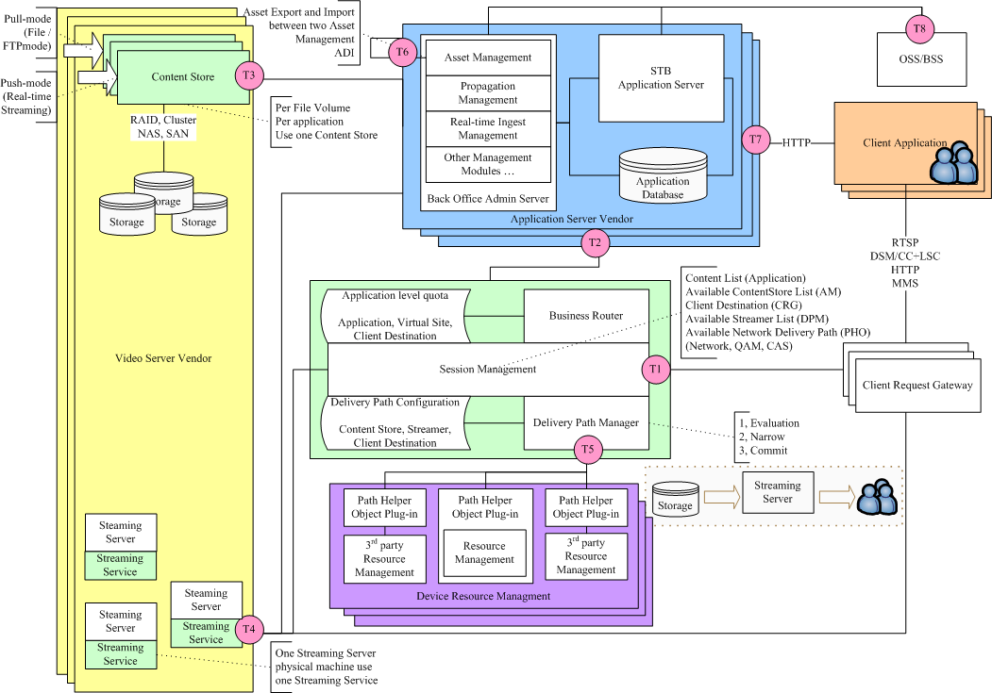
Figure 1 Reference Architecture

Logical Components
TianShan On-Demand Architecture is partitioned functionally into a number of logical components. Each component is defined in a way that the interchangeable module implementation the common interfaces can be introduced to work with the rest of the system. For example, multiple video servers can be introduced into the system as long as they implement the defined interfaces. On other hand, it is anticipated that in some cases, implementations may integrate several components into a single product or solution.
The key logical components include:

- Stream Service (SS) | A software module manages the local video stream devices, takes the stream setup and stream control commands to drive the stream behavior
- Content Store (CS) | A software module manages a single file-based volume for media contents
- Session Manager (SM) | A software module manages life cycle of session for On-Demand applications requested by subscriber
- Business Router | A software module dispatch the subscribers’ requests to proper application service and also manages the per-site and per-application quota
- Path Manager | A software module provides network abstraction for streaming transport
- Path Helper Object (PHO) | A plugin module associates a specific linkage in the network abstraction
- Client Request Gateway (CRGw) | A software module accepts the requests from client applications via various communication protocols, such as RTSP or DSMCC/LSC, and translates the requests into TianShan APIs. It also generates responses to the client applications
- Asset Manager (AM) | A software module manages life cycle of media assets and their metadata

Interfaces
The primary intention for this open architecture is to define and standardize the interfaces among various components. The interface definitions cover both data structure and controls. The TianShan On-Demand Architecture provides the interface definitions mostly via an object-oriented manner. In such a way, the interfaces are well organized with the benefits of modularization, abstraction, hierarchy and continuity.
On the other hand, The TianShan On-Demand Architecture shall take the advantages of mature technology that has already been proven. For example, the SNMP is used in the architecture to manage and monitor all the headend components.
The following are key interfaces grouped as categories:

- Session | Represents the lifecycle management, factory and state machine of the TianShan sessions  Its Business Router maps virtual sites and applications to the portable application services. It is also a per-site and per-application quota management.  Its Path Manager represents TianShan’s abstraction of on-demand video network
- Application | Represents a unified entry definition of a business application
- ContentStore | Represents a media content storage
- Stream | Represents the stream device and streaming management
- Path Helper | A plug-in interface to associate a specific linkage type in the TianShan network abstraction
- Asset | Represents the asset management interface. It may be defined via some existing manners such as CableLab ADI
- Navigation | Represnts the interfaces between client application and the headend application service. It can be defined via various protocol such as HTTP, VODLink and more
- Billing

Stream Transport Network Abstraction
It is desirable to support various Stream Transport networks within one same architecture. The TianShan On-Demand architecture introduces an abstraction layer for the Stream Transport networks. In such an abstracted definition, the devices in a Stream Transport network are grouped as three entities and two categories of linkage among them.

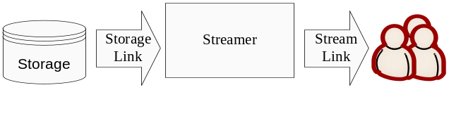
Figure 2 VideoTransport Network Abstraction

With the abstracted network definition, the TianShan On-Demand architecture is able to manage various network devices on the topology by using a unified manner and reduces much complexity of various network topologies.

Entities
In this network abstraction, the Stream Transport network devices are grouped as three entities:
- Storage | The storage devices in which stores the video media content files with an involatile manner such as disk. Every storage represents a single file volume
- Streamer | The device to stream off video media contents. It converts the filebase media contents to network streaming traffic. Each streamer represents a device with a physical wired interface from the stream server
- Service Group | Represents a group of destination subscribers logically or physically:  - The subscribers within a service group may belong to a specific virtual site logically;  - The subscriber within a service group may be the client application device physically located in a specific neighborhood

Linkages
The three entities are linked via two categories of linkages:
- StorageLink | This category represents the linkages from the storage to the streamer. The linkage defines the methods how the stream service can access the media content files with necessary parameters.
- StreamLink | This category represents the linkages from the streamer device to the destination subscribers. The linkage defines the methods how the stream service can pump the streaming traffic to the destination, such as thru a specific edge device or network router

A Stream Transport Path
Each Stream Transport path in the TianShan architecture consists of a specific instance of the three entities (storage, streamer and service group) and a specific storagelink (the storage instance to the streamer) and streamlink (the streamer to the servicegroup). The stream service that owns the streamer device is responsible for fetching the contents from the storage and pumps the streaming traffic to the destination service group

Evaluation and Selection
For an individual on-demand order, a headend may have several potential Stream Transport paths available to perform the streaming. In the TianShan On-Demand architecture, a procedure, in which first evaluates the cost of each potential path then pick one by referring the collected cost values, is defined to select an effective transport path.

Non-cached and Cached Streaming
Based on the access methods that a stream service takes to access the media, two streaming architectures can be grouped as the following:
- Non-cached streaming | The stream service directly read the media content from the storage for each stream session. The contents will not cached in the stream server’s local storage and will not shared across the stream sessions performed by the same stream service.
- Cached streaming | In this streaming architecture, the stream service will cache the media contents to its local storage wholly or partiatly first then start streaming from its local cache. The cached content may be shared across the stream sessions performed by the same stream service
In a non-cached streaming architecture, the Stream Transport path evaluation is quite per-session. The cost will be based on the stream session independently, mostly be based on the bandwidth reservation on the link, for example:

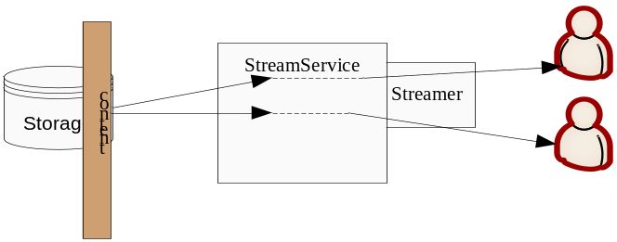
Figure 3 Non-cache streaming

In a cached streaming architecture, the stream service caches the content from the storage to its local storage first then stream off for quality or effective load dispatching purposes. The cached contents may not be shared across different stream sessions of the same stream service, see Figure 4 Cached Streaming w/o Sharing. In such a case, the cache is mostly designed for streaming quality, the Stream Transport path evaluation will be session based, please refer to the above non-cached streaming.
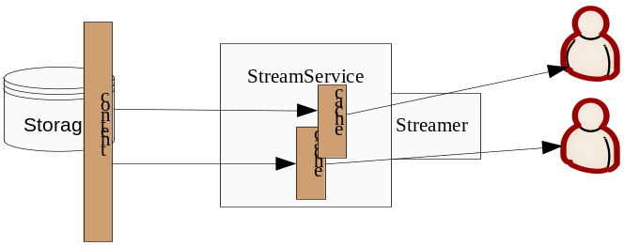
Figure 4 Cached Streaming w/o Sharing

The cached contents can be usually shared across the different stream sessions of the same stream service in the most of existing cached video servers, see Figure 5 Cached Streaming w/ Sharing. In such a way, the stream service has no need to fetch the content data from the storage if it has been cached locally, the potential cost for streaming such a cached contents is lower than usual. The cached streaming mentioned in TianShan On-Demand architecture means the one with sharing unless there was a specific indication.
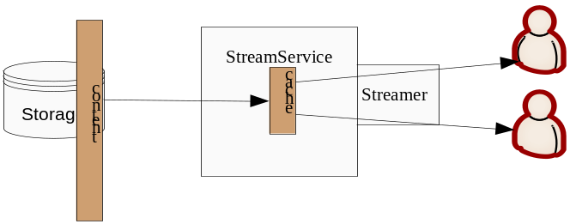
Figure 5 Cached Streaming w/ Sharing

For those stream sessions that must perform content caching, the caching cost must be considered properly thru the storage link evaluation.

Session and Resource Management

Virtual Hosting
The term Virtual Site in TianShan refers to the practice of running more than one video site (such as SiteForHotelA and SchoolsInTravisCounty) on a single physical headend. Virtual sites are name-based, meaning that the system has multiple site names running on a physical headend.
With name-based virtual site hosting, the headend dispatches the client’s requests to different business applications based on the site name as part of the request URI. Using this technique, many different sites can share the same physical headend.

Some ancient client protocols are not compatible with name-based virtual site hosting. For example, the requested asset or content for the On-demand application are in a numeric format in the protocol or hard to be formatted in the URI string.

Quota Management
The administrator of the headend is able to define quota for each hosted virtual site

Per-virtual-site storage quota
Every virtual site is able to utilize its own private media content storage or share the storage with other virtual sites. The quota management harmonizes storage quotas for those virtual sites.

Per-virtual-site streamer quota
Every virtual site is able to utilize its own private streamer device or share the streamers with other virtual sites. The quota management harmonizes the streamer devices for those virtual sites.

Runtime session and bandwidth Quota
Every virtual site can be granted with a maximal amount of current sessions or streaming bandwidth.

Typical Deployment Configuration

Transactions and Statistic
The system should record all the on-demand transactions including the order information, associated virtual site and application and the time stamps in a database. The transactions can be used for audit purposes among multiple virtual sites.

Core work flow
This section describes the reference work flow of some core operations in the TianShan On-demand architecture as a design guide. The implemented work flow may have more details or some minor optimizations up to the integration and is beyond the scope of this specification.

Setup an On-Demand Session
The Figure 6 briefly describes the work flow how an on-demand session is created in the system powered by TianShan On-Demand architecture.

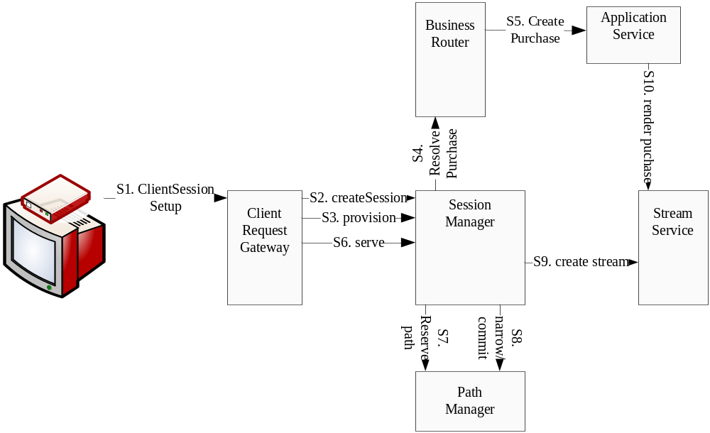
Figure 6 Setup an On-Demand Session

In which,
S1 | The client application (maybe on the set-top box) send a request to the headend service to set up a session
S2 | The client request gateway parses the request from the client, and call the session manager to create a server session for this client order
S3 | Once the server session is created, the client request gateway asks the session manager to provision the session
S4 | The session manager ask the business router to resolve an application purchase for the session
S5 | The business router addresses the proper value-add business application service, and asks the application service to create a purchase instance to associate the session. Some quota limitation and order-oriented limitation may also be applied onto the session during this step.  At the moment the session has been provisioned
S6 | The client request gateway asks the session manager to serve the session
S7 | The session manager will ask the path manager to reserve some potential Stream Transport paths, see 3.4, with cost evaluation results
S8 | The session manager will select one nearly cost-effective path from the reserved paths, and narrow the resource then commit to use
S9 | Based on the selected Stream Transport path, the session manager will contact the stream service, who manages the streamer of the selected path, to create a stream.
S10 | Session manager asks the application service to render the purchase onto the created stream instance, the latter fills in a list of media contents with attributes. The on-demand session becomes ready to go at the moment

Purchase Resolving and Quota Validation
The Figure 7 details the above S4-S5 during the session setup.

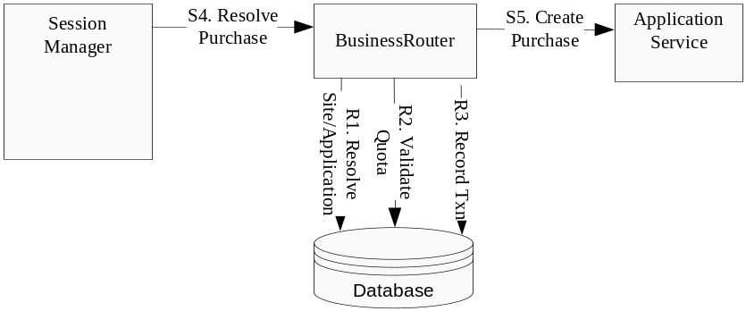
Figure 7 Resolve Purchase and Quota Validation

In which,
S4 | The session manager ask the business router to resolve an application purchase for the session
R1 | The business router query the database and maps the URI of the client order to the associated virtual site and the value-add business application service
R2 | The business router validates the order with the quota management. Some order may be rejected at this step
S5 | The business router addresses the proper value-add business application service, and asks the application service to create a purchase instance to associate the session. Some quota limitation and order-oriented limitation may also be applied onto the session during this step.  At the moment the session has been provisioned
R3 | A transaction record will be committed once a session is successfully provision-ed

Session State Diagram
The Figure 8 describes the states of a session during its lifecycle.

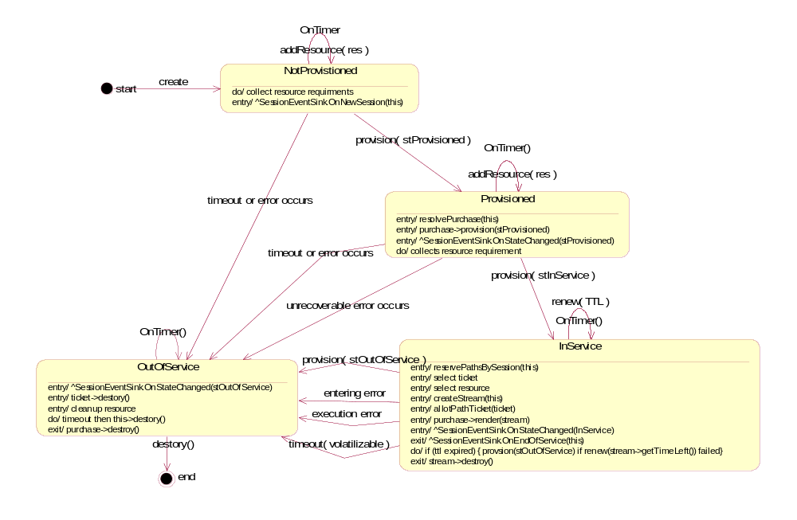
Figure 8 Session State

Stream Control
The Figure 8 describes how a stream control request will be handled in the system powered by TianShan On-Demand architecture.

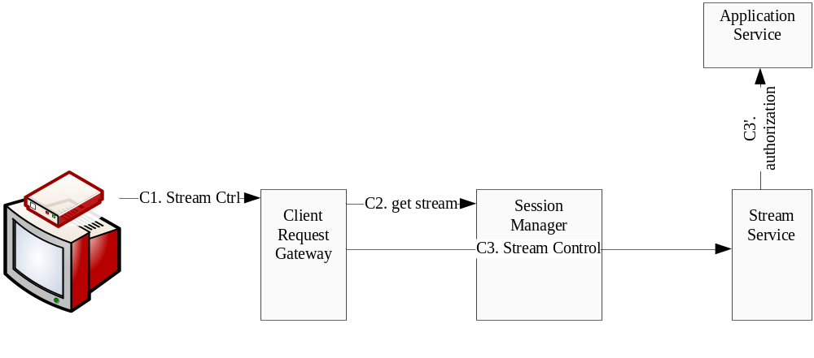
Figure 9 Stream Control
In which,
C1 | The client application (maybe on the set-top box) sends a stream control request to the headend service. For example, fast forward, pause or rewind the stream
C2 | The client request gateway parses the request from the client, and address the stream instance bound on the associated session
C3 | The client request gateway calls the stream service who owns the stream instance to apply the stream control operation on it
C3’ | If necessary, the stream control request will be passed to the attached application service for authorization

Logical Component Descriptions

Content Store

Content Store Service
The ContentStore in TianShan On-Demand Architecture is a logical service that manages media content files in storage(s) and exports the storages by file volumes. The physical storage can be various up to the ContentStore implementations from different vendors. It can be a local hard drive or a sub tree on a disk partition, or even an external NAS system.
The ContentStore a file-like access to the media contents in the storage.
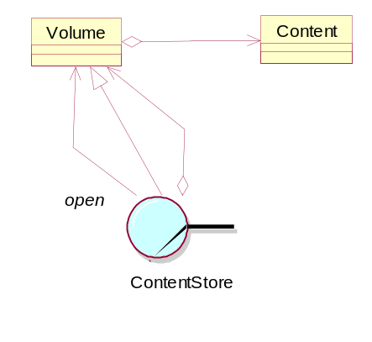
Figure 10 ContentStore Class Diagram

Those content accesses includes
- Open the access to the volume
- Create a media content or open an existing content from a volue
- Delete a media content
- Query the basic attributes of a content, such as the create-time, length
- Query media attributes of the content, such as MPEG bitrate and playtime

In a TianShan powered deployment, ContentStore may consist of multiple volumes, but no across ContentStore overlapping storage is allowed.

Content Provision Engine
Contents must be provisioned before becoming available in a ContentStore; it can be as simple as a file copy procedure, while many existing ContentStore requires the content being imported to meet its own specification. Media transcoding may be necessary in these cases. The content provision may be handled on additional machines if the transcoding costs highly.
Every content provision should cover three sub-procedures:
- Fetching the source content
- Media process or transcoding
- Distribute the result content onto the destination storage(s)
The content provision will be under the management of a ContentStore service. Figure 11 shows a content provision reference architecture.

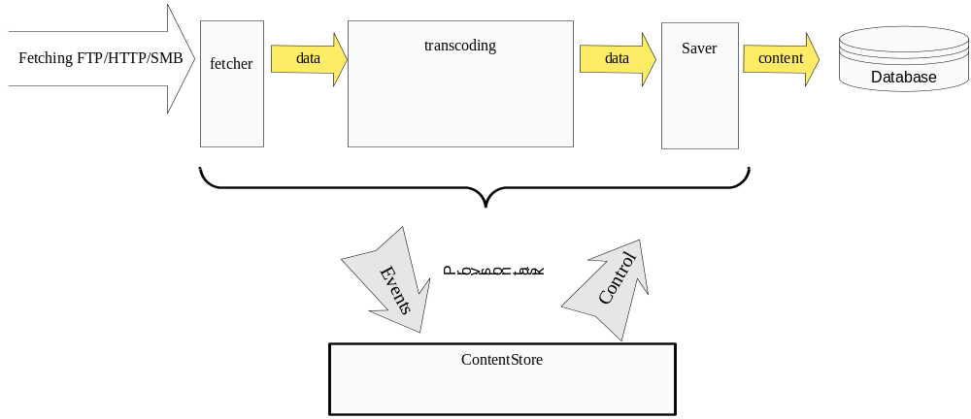
Figure 11 Content Provision

Please refer to ContentStore documentation for more details

Stream Service
The StreamService in TianShan On-Demand Architecture is a logical service that runs on a stream server and manages the streamer devices available on the stream server. It is also responsible for managing the streaming instances.
Typically, single or multiple StreamService may be deployed across the network.
The StreamService also provide an interface to allow control its streaming instances with the VCR-like stream controls such as pause, fast forward, fast rewind and so on.

Session and Path Management Kit

Session Manager
The Session Manager in TianShan On-Demand Architecture is a logical service that is responsible for managing the life cycle of sessions for on demand applications.
The on-demand value-add applications will require the establishment of sessions. A collection of server and network resource needs to be reserved for the session for a certain or uncertain duration of time.
The Session Manager should cover:
- Accepts the requests with the client applications, normally redirected by the Client Request Gateway, regarding session setup and teardown;
- Export or report the session status to those components it may concerns
- Associate the on-demand session with value-add application purchase
- Collect the resource requirements for the session
- Allocate the resources by negotiating with the resource managers, redirectly thru the path management;
- Manage the life cycle of the sessions

Business Router
Business Router represents a logical service that is responsible for dispatching the on-demand session to the appropriate value-add application service. It
- Manages the hosted virtual sites and maps the associations to the appropriate value-add application service.
- Performs quota management for virtual sites and applications

Path Manager
The Path Manager is a logical service that is responsible for abstracting various network topology and various network components into a unified Stream Transport path definition. It
- Simplifies and unifies the networks for the session manager
- Proxy the resource allocating and negotiating with external resource managers for the session manager
- Acts as a resource manager for appropriate server and network components when the external resource manager is unavailable.
- Provides a plugin framework to populate multiple path helper objects as plugins

Path Helper
The Path Helper, or Path Helper Object, represents a software plugin that is response for resolve the allocation, negotiation for one or multiple specific link type in the Stream Transport path definition of TianShan network abstraction.
The plugins are distributed as DLLs on Microsoft Windows or SOs on Unix-like operating systems.

The Weiwoo Service
The Weiwoo service is a session and path management implementation by ZQ Interactive. It covers the above session manager, business router, path manager and various path helper objects.

Resource Manager
The Resource Manager is a logical service that is responsible for allocating and managing a certain category of headend resources appeared on the Stream Transport path.
Path Manager is a special resource manager that manages ContentStores and StreamServices. Resource Manager mentioned in TianShan On-Demand architecture means those manage the resources other than ContentStores and StreamServices unless there was a specific indication.
When a required resource is under management of a resource manager, the involved Path Helper will communicate with the resource manager for allocation and negotiation.

Content Caching
In a cached streaming architecture, contents must be partially or fully cached before being streamed off from the stream server. This caching may involve some external resource, the path helper object associates for this specific StorageLink type will communicate with the necessary external resource manager for resource allocation and negotiation. The resource manager that manages the resource involved in this content caching is responsible for allocating the resource to respond the path helper object.

Conditional Access and Encryption
Conditional Access System (CAS) may be used to ensure specific users to render the limited streams especially for the real-time encryption. The encryption may borrow the power of external devices, other than the stream server itself, before the edge devices. A resource manager may be involved in this case and is responsible for managing the encryption engines and provision the encryption recourse required by sessions.

Streaming Network and Devices
A collection of network devices may be involved from the streaming traffic is pumped by streamer device to the destination client. Several resource managers may be responsible for allocating the various resources:

Control-able IP transport network
A resource manager may be responsible for the allocating on an IP transport network with control-able switch, router or other network devices

QAM devices
In some network to the clients, such as HFC, QAM devices are request to convert the MPEG traffic to modulated signals. A resource manager may be involved and is responsible for allocating and managing the resources that rare required at those devices such as QAM bandwidth.

The path helper object associates for those certain type of StreamLink type will communicate with the necessary external resource manager for resource allocation and negotiation.

Client Application
The client application is defined as a collection of the software modules at the digital set-top box and/or any end-user applications that may run on some terminal PCs. A client application can receive the network streaming traffic and render it on the terminal display. And it has user interface to interact with the end-user such as navigation, remote control operations and more. It may have a backward digital channel to the headend to delivery to the end-user’s requests.

Client Request Gateway
The Client Request Gateway is a collection of logical services that are responsible for receiving the requests from client application and covert the request to a sequence of appropriate TianShan invocations.
Typically, the client applications from different vendor will take various possible protocols. RTSP, DSM-CC / LSC, MMS and HTTP are the most popular protocols used in on-demand client applications. However, there are also a number of user-defined protocols used in many deployments. Even for those standard protocols, such as RTSP, user-defined extension can be often found. The client request gateway can be implemented per such a client protocol or customized for a specific deployment.
For those client communications built based on connection-oriented protocols, such as RTSP over TCP, multiple client request gateway may be installed up to the deployment.

The RTSP Proxy
The RTSP proxy is a software service distributed with ZQ TianShan installation kit. It intends to convert the standard RTSP protocol to TianShan core invocations without introducing distortions on the user-defined RTSP extensions. It should fit most of the deployments that are using RTSP over TCP as the communication protocol to the client applications.

Event Delivering and Monitoring
The event delivering and monitoring subsystem consists of several logical modules to assist the core TianShan modules.
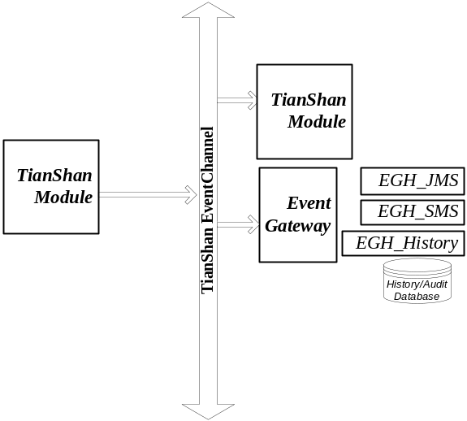
Figure 12 Event Channel

Event Channel
In the TianShan architecture, the event is defined as a one-to-many delivering. The event channel is a service to the provide this one-to-many delivering. All the events are collected from various TianShan module instances, and are posted into this event channel, the event channel then deliver those events to the interested parties.

Event Collecting
Each event includes the information of the instance that generates the event, the type and code of the event, the optional parameters carried in the event. Those events can be gathered in two ways:

Direct Post
For the time-critical events, the module may directly post the events into the event channel.

Parse and Collect
An additional module may be defined to collect the events from the core modules then compose the event and forward to the event channel. This can be used for those events that have no critical needs on delivery latency, but can help the core module to wait less

Event Re-distributing and Alarm
EventGateway is a plugin framework work as a generic event subscriber of the event channel. It loads EGHs (Event Gateway Helpers) to redistribute the specified event to interested parities thru various manners, such as Java Messaging, Mobile SMS and so on.
Up to the implementations of the EGHs, the interested events can be delivered as alarms to the administer for the ciriticla events or even just simply trace the records into the historical database for late audit

The Sentry Service
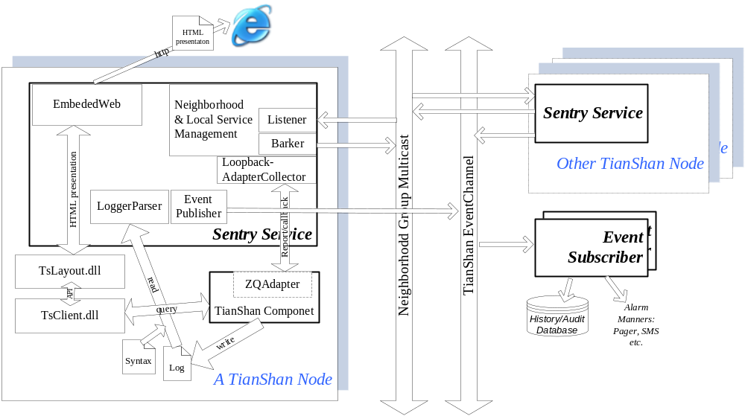
Figure 13 Sentry Service

As the major component in the event collecting and monitoring subsystem, Sentry service is deployed on each node, and consists of the following major functions
Web Presentation | Through various web pages, the Sentry gives a UI to  - Confirm the settings of a running module  - Support the queries on the running status  - Support simple administration thru web pages  - Support log view of any local TianShan modules for remote debugging
Event Collector | Collects the events from the log files of the local TianShan modules and redirect them onto the event channel
Neighborhood Management | Detects the neighborhood and link up the remote sentry service as a distributed monitoring subsystem

Value-add Application
The value-add application is a collection of logical entities to abstract application specific logic of on-demand business modes.

Application Service
The application service is a logical service implements the ApplicationService interface of TianShan.
- In response to other TianShan components, the service provides the functionalities defined in the ApplicationService interfaces, and may
- Access other TianShan components by invoking their interfaces;
- It obtains information necessary for the on demand application from other components, such as the subscriber entitlement information

Asset Resolving
Asset in an on-demand system includes asset metadata and media contents. The asset management system manages the lifecycle of assets. It provides a number of functionalities:
- Receiving and storing of assets
- Asset metadata schema definition
- Asset metadata operations such as validation, modification
- Asset contents association
- Asset life cycle management such as create, modify, delete and so on

Global shared asset managment
In an on-demand system powered by TianShan, the assets may be under a global management. The assets are shared across various application services. Each application service may have different view of the assets that they can access from the shared asset management

Private asset managment
The TianShan on-demand architecture also allow every business application to have its own private asset management, in which the asset association is private and may be different from those of other asset managements. Metadata may have different schema and asset-to-content may have different associations in the different private asset managements.

Propagation and Replication
Asset manager may manage the asset propagation among multiple appropriate content stores by itself, but most likely a separate component may assistant it on this. Such a component is called as propagation service.
Asset propagation should cover
- The invocations to drive content to perform a lifecycle management of contents, such as create and delete
- Be able to query storage capacity of a content store and determine the propagation based on policies
- Is responsible for the queries about asset replications on multiple content stores
The propagation may appear as a central management in the system respond to a global asset management or is shared by multiple private asset managements. It is also possible for each private asset management owns its propagation base on its private content stores.

Ingestion Management
It is possible from some applications that media sources are encoded real time or recorded from a real time broadcast feeds. The ingestion management is a components that
- Drives content provision thru ContentStore to ingest contents in real time
- Completes asset in respond to per-application asset definition and imports asset metadata from some real-time manner such as the broadcast EPG

Asset Navigation
The navigation service is another assistant system of the asset management, the navigation service obtains necessary information for the on-demand value-add application from other components, mostly from the asset management, and represent the navigation menu and related application features to the client application and exchanges messages with the client application to enable the navigation functions.

Interface Descriptions
The interfaces identified in TianShan on-demand architecture are be defined in an open, non-proprietary fashion to facilitate multi-vendor environments for deploying on demand applications. To reach the goals of specifying the TianShan on-demand infrastructure,
it is desirable that the interfaces between the various components are defined in an object-oriented language, which could provide lot of pleasure for the vendor to follow and cut engineering efforts. Most of the TianShan interfaces are defined as object-oriented definition, in such a way; those interfaces are well organized with the benefits of object-oriented engineering:

Modularization
This allows the TianShan on-demand architecture to be defined in a natural way and be divided into some separate components with clear meanings and reduce complexity. The vendors of the involved devices can focus on the functionality they should provide and be able to adopting in the all the system powered by TianShan.

Abstraction
The TianShan reference architecture provides a number of service interfaces reflect logical components and their communications. In actual development, that is in the implementation, those interfaces may be implemented in different ways up to the different vendors. Since all of them follow the same interface definition, those different implementation and products can be interchangeable under the TianShan On-demand architecture.

Continuity
The interfaces of in the TianShan on-demand architecture can be maintained continually with object-oriented definition

ICE Basic
The TianShan on-demand architecture uses Internet Communications Engine (ICE) technology on it object-oriented interface definition. ICE is an object-oriented middleware platform provided by ZeroC. Ice applications are suitable for use in heterogeneous environments: client and server can be written in different programming languages , can run on different operating system and machine architectures, and can communicate using a variety of networking technologies,. The source code for these applications is portable regardless of the deployment environment.

The ICE technology provides a number of benefits to application developers:
- Object-oriented semantics
- Support for synchronous and asynchronous messaging
- Support for multiple interfaces in one object implementation
- Machine and OS independence
- Programming language independence
- Implementation independence
- Threading support
- Transport independence
- Location and server transparency
- communication security
- Built-in object persistence
- Open source
Please refer to ZeroC’s documentations for more details about the ICE technology

Manageable Services

Content
The content related interfaces, as shown in Figure 14, include interface T3 series. They are primarily responsible for managing the contents, in a file volume, in a file-system-like access. In addition, they are also responsible for drive and monitor content provision procedures.
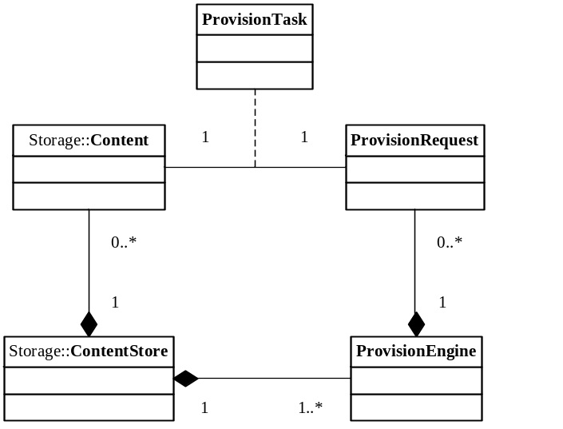
Figure 14 Content Interfaces

ContentStore (T3)
The ContentStore is the interface exported by a service intends to represent the basic functionalities to manage the storage and delivery of Content files. The functions it publishes for such use are equivalent to virtual functions, which must be implemented by any derived classes.

- The main function of a ContentStore is to open access to a content object, a user may also use the same method to create a new content on the ContentStore. Besides this, the ContentStore also
- Responds the queries for storage-wide attributes such as the ContentStore capacity; and
- Allow user to subscribe the events occurs in the ContentStore

Content (T3.1)
The Content is a base class definition, which is intended to represent the basic functionalities to access an individual media content files. The functions it publishes for such use are equivalent to virtual functions, which must be implemented by any derived classes.
Through the content definition, a use will be able to
- Drive the ContentStore to do content provisioning with specified parameter such as schedule information
- Query the basic content information such as size, create time etc
- Query the media information such as bitrate, playtime, resolution etc
- Query the provision information such as the provision state, the source URL where the content was fetched from

Provision (T3.2)
The Content ProvisionEngine interface allows a ContentStore to utilize the power of the provision engine:
- Specify the source URL where and how to fetch the source content
- Specify the source type of media content and let the provision engine decide how to transcode and prepare the content
- Specify the destination storage that the result content should be stored on
- Allow user to subscribe the events occurs during the provision procedure, such as start, end, progress and error occurs

Stream
The stream related interfaces, as shown in Figure 15, include interface T5 series. They are primarily responsible for managing and control the stream instances.
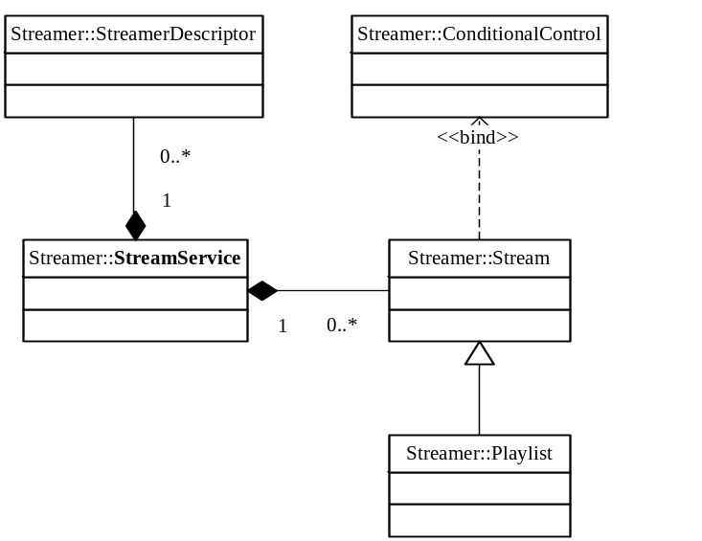
Figure 15 Stream Interfaces

StreamService (T5)
The StreamService is the interface exported by a service intends to represent the basic functionalities to manage the stream instances. The functions it publishes for such use are equivalent to virtual functions, which must be implemented by any derived classes.

A StreamService is a factory of stream instances; the main function exported from a StreamService interface is to create a new stream instance. It is also an aggregator of the local streamer devices on the stream server, users will be able to query all the streamer descriptor managed by the StreamService.

Stream and Control (T5.1)
Other components control the stream behaviors through the Stream interfaces. The Stream interfaces allow user to
- Destroy and terminate the stream instance
- Play the stream or start streaming
- Pause and resume the stream
- Change the stream speed
Also the Stream interface allow people to get the access to the associated session

Playlist (T5.2)
The Playlist definition inherits from the basic Stream interface with the extended operations of a server-side playlist:
- Insert an item into the playlist
- Append an item into the playlist
- Erase an item from the playlist
- Find an item in the playlist
- Skip to play a specific item
- Seek to a specific position

Conditional Stream Control (T5.3)
The ConditionalControl is defined as a callback that can be hooked into any Stream instances. Whenever a interested stream control operation comes, the stream instance will query the ConditionalStreamControl owner for authorization. The interest of the specific stream control operations is defined as a mask:
- Approve | The StreamService directly approves this stream control without asking anyone else
- Deny | The StreamService directly denies this stream control without asking anyone else
- Authorize | The StreamService must asks external module to authorize this stream control via ConditionalControl callback

Session and Resource
The session related interfaces, as shown in Figure 16, include interface T1 series. They are primarily responsible for session setup and tear down as well as other session management functions. The Stream Transport network abstraction of the TianShan On-demand architecture is also covered in the path management in this category.

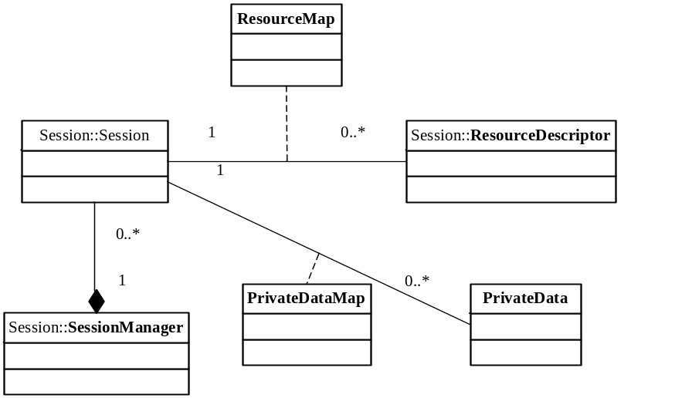
Figure 16 Session Interfaces

This session related interfaces also define the resource descriptors as they are carried in every session instance.

Session Manager (T1)
The SessionManager is the interface exported by a service intends to represent the basic functionalities to manage the session instances. The functions it publishes for such use are equivalent to virtual functions, which must be implemented by any derived classes.

A SessionManager is a factory of session instances; the main function exported from a StreamService interface is to create a new session instance. The session instances are under control of a state machine inside of the SessionManger.

Session and Control (T1.1)
Other components access and control the session through the Session interfaces. The Session interface allows user to
- Destroy and terminate the session instance, all the resources, stream or any other objects allocated for the session will be cleaned up too
- Drive and query the session state
- Add and query the resource descriptors bound on the session
- Add and query the private data carried by the session
- Get the access to the object instances bound on the session, such as stream, purchase etc

Resource Descriptors (T1.2)
Resources are defined in many different manners by various existing systems. In order to unify the definition, resources are described via resource descriptors in the TianShan On-demand architecture. A session instance carries a collection of resource descriptors to pass the information of those resource associated with it.

The following briefly lists some important resources in the TianShan architecture:
- URI | The required resource identity of order in URI format
- Storage | The storages identified with a collection of ContentStore network Id or type
- Streamer | The streamer devices identified with a collection of streamer network Id or type
- ServiceGroup | The destinations identified with a collection of servicegroup Id
- MpegProgram | The resource of MPEG covers parameters such as program number, PIDs
- TsDownstreamBandwidth | the resource to indicates the desire to allocate a quantity of bandwidth on a given transport stream
- EthernetInterface | the resource to to convey NIC address for ARP stream pumping
- PhysicalChannel | Describes the channel used for tuning sessions. The channelId field is the QAM frequency in hertz.
- HeadendId | the resource to reserve for allows for a single service server to support Sessions in multiple headends
- AtscModulationMode | the resource to reserve to convey information to the set top about tuning information

Path Manager (T1.3)
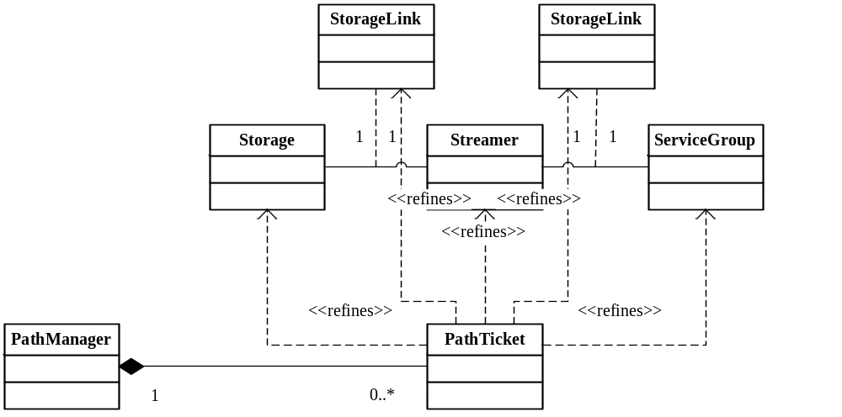
Figure 17 Path Manager

The PathManager is the interface exported by a service intends to represent the basic functionalities to abstract the Stream Transport network and manage the path allocation. The functions it publishes for such use are equivalent to virtual functions, which must be implemented by any derived classes.

A PathManager is responsible for abstracting the various transport network by managing the entities (storage, streamer an servicegroup) and linkages (StorageLink and StreamLink). It provides a plugin framework to populate Path Helper Objects to support different entities and links. It acts as a resource manager itself for the abstracted paths, and also is an allocator of the resource on the Stream Transport paths by communicating with external resource management.

The main function exported by it is to reserve a list of potential Stream Transport path, besides this, it also provide a series of methods to administrate the entities and linkages.

Path Ticket (T1.4)
The allocation results are represented through Path Ticket instances. Every Path Ticket presents a potential Stream Transport that a session may utilize. The Path Ticket definition allows other components to
- Destroy the ticket and withdraw all the resource allocated
- Query for evaluation cost
- Get the access to the entities or linkages associated on the path
- Renew or query the lease term for the allocation

Path Helper
The Path Helper related interfaces include interface T4 series. They are responsible for a plugin framework to populate a number of third party path helper objects to support various video network topologies and components

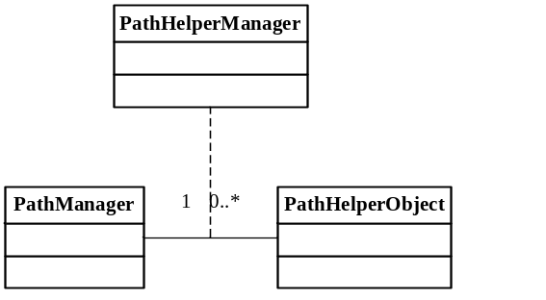
Figure 18 Path Helper

Path Helper Object (T4.1)
The Path Helper Object is the interface exported from a Path Helper plugin to responds the communication from Path Helper Manager about path evaluation and narrowing.

One path helper object will cover one or multiple link types, it implements
- How to do the cost evaluation for the specific StorageLink or StreamLink type regarding the detailed parameters
- How to narrow the resources bound on an allocated potential path by negociating with external resource management if necessary
- How to free the resources bound on the allocated path

In addition, the Path Helper Object also defines the parameter schema of the specific link types and also performs the link parameter validation and upgrading

Path Helper Manager (T4.2)
The Path Helper Manager is an internal module of Path Manager; it is an aggregator of the multiple Path Helper Objects that populated when the service is started. The interface Path Helper Manager exported from Path Manager allows the Path Helper Objects’ implement to access necessary server objects during the cost evaluation and narrowing.

Application and Purchase
The value-add application related interfaces include interface T2 series plus T1.5, which is a part of session management. They are responsible for associating a user’s order with a purchase in a proper application service and render the purchase in the session.
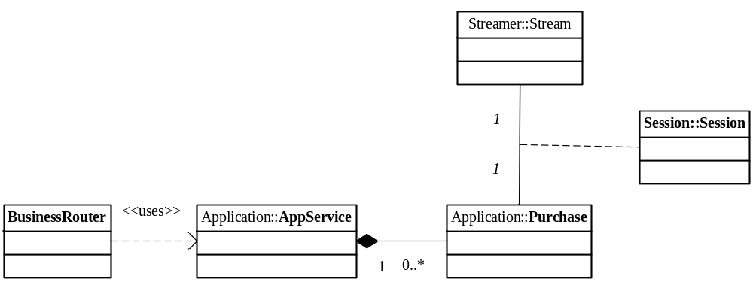
Figure 19 Application Interfaces

Purchase Resolving (T1.5)
The BusinessRouter exports a function to resolve the purchase instance on a proper application service by the session.
During the resolving, BusinessRouter is responsible for addressint the proper application service and validating the order with quota management, then ask the application service to associate the session with its purchase instance.
The resolving functions it publishes for such use are equivalent to virtual functions, which must be implemented by any BusinessRouter implementation.

Application Service (T2)
The AppService is the interface exported by a service intends to represent the basic functionalities to render an on-demand order as a video streaming. The functions it publishes for such use are equivalent to virtual functions, which must be implemented by any derived classes.
An application is a factory of purchase instances; the main function of it is to create or associate the appropriate purchase by the given session

Purchase (T2.1)
A purchase represents a component of a application oriented session. Other components access the application session through this Purchase interface. The Purchase interface allows user to
- Drive the Purchase to the perform necessary provisioning steps
- Render the purchase onto a instanced stream object
- Get the access to the session bound
- Record a bookmark

Client Request
In order to setup and control the on-demand sessions, the client request interface defines the protocols between the client application and Client Request Gateway. The site may choose the proper protocol from a potential set including those well known protocols, such as RTSP, MMS, HTTP, DSMCC, LSCP and so on. People may develop ClientRequestGateway for the client request interface built on the selected session and control protocol. They may define some more to extend the basic protocol such as RTSP to satisfy their application to add more values

RTSP is an example natively supported and shipped with SeaChange/ZQ TianShan implementation. Please refer to SeaChange RTSP Specification (TianShan Edition) for more details.

Interface Extensions Needed in Business Modules
To build up a complete system, some interfaces are considered to associate the core TianShan system. This section enumerates some reference interface definitions for this puposes.

Most of video servers are known as a server that consists a set of controllable video streamer devices with or without storages. The TianShan architecture represents the interfaces of streaming and storage in its core definition. Those contents on the storage may be organized as assets in many systems, it is up to the extended business module how to do so.

Asset Distribution (T6)
The interface of asset distribution defines how to organize an asset used in the business modules. Each asset may consist of media contents and a set of meta data such as title, actor, prize, etc. The business modules may keep the containing relationships and meta data in its database, and guide the storages to import the media contents thru ContentStore and ContentProvisionEngine interface
The Asset Distribution interface is designed to cover how the asset information can get imported into the business modules. In which, the ADI interface is a widely-used in the industry today.

Navigation
To present the available assets or programs to the end users, this interface may be required in the business modules. The client applications query for assets or programs thru this interface and show related information, such as the poster and prize of an asset, on the screen. A popular implementation on this would be HTTP-based protocol and display thru embedded browser on the client application.

Subscription Billing (T8)
The extended business modules must provide its billing system to bill the subscribers. There are various third-party billing systems available. It is up to the business mouldes to pick the integration interfaces, BOSS (Billing and Order Support System) definition can be a popular standard for the interface to follow

Architectural Recommendations

Overview

Dummy Resource Management

Broadcast Applications

Appendix

ContentStore and StreamSmith on SeaChange MediaCluster

ChannelOnDemand Application for PauseTV

Key to Document status Codes: Work in Progress (W)An incomplete document, designed to guide discussion and generate beedback that may include several alternative requirements for considerationDraft (D)A document in specification format considered largely complete, but lacking review by other vendors. Drafts are susceptible to substantial change during the review processIssued (I)A stable document, which has undergone rigorous vendor review and is suitable for product desing and development, cross-vendor interoperability, and for certification tesing.Released (R)A stable document, reviewd, tested and validated, suitable to enable cross-vendor interoperability
Path cost is an integer number in the range of 0 to 10000 in TianShan. Cost 0 means the lowest cost and is highly recommended to take; while cost 10000 means it is highly unavailable.

